

[**Pyanshu Shaw**](https://www.linkedin.com/in/pyanshu-shaw-2157362b1/)

**pyanshu2001@gmail.com**

HOTEL

MANAGEMENT

SYSTEM



**Project By – Mr. Pyanshu Shaw**

Abstract

The **Hotel Management System** is a database-driven project designed to streamline hotel operations, including room booking, guest management, billing.

Built using **MySQL** for efficient data storage and retrieval, the system ensures seamless management of reservations & check-ins/check-outs.



**HOTEL MANAGEMENT SYSTEM**

**Description:**

The **Hotel Management System** is a database-driven solution designed to streamline hotel operations, enhancing efficiency and guest satisfaction. Built using **MySQL**, this system centralizes key functions such as **guest reservations, room management, billing, and staff coordination** into a single, user-friendly platform.

The system allows hotels to **manage bookings in real-time**, track room availability, automate invoices, and maintain guest records securely. Staff can efficiently handle check-ins/check-outs, assign rooms, and generate reports on occupancy and revenue. Administrators have controlled access to oversee operations, update pricing, and manage employee roles.

By reducing manual workload and minimizing errors, this system improves service speed, accuracy, and overall hotel management. It is ideal for **small to mid-sized hotels** seeking a reliable, scalable, and cost-effective digital solution.

**HOTEL MANAGEMENT SYSTEM**

**1. Problem Statement**

* **Manual inefficiencies:** Traditional hotel operations rely on paper-based records, leading to slow check-ins/check-outs and booking errors.
* **Overbooking risks:** Without real-time room tracking, double bookings occur, causing customer dissatisfaction.
* **Billing errors:** Handwritten invoices and payment calculations are prone to mistakes, leading to revenue loss.
* **Poor data management:** Disorganized guest histories, staff records, and inventory make reporting and decision-making difficult.
* **Security concerns:** Unauthorized access to sensitive guest and financial data due to lack of a secure system.

**2. Objectives**

**A. Automate Operations**

* Replace manual processes with a digital system for **booking, check-ins, check-outs, and billing** to improve efficiency.

**B. Prevent Overbooking**

* Implement **real-time room availability tracking** to eliminate double bookings and optimize occupancy.

**C. Ensure Accurate Billing**

* Automate **invoice generation, payment tracking, and receipt management** to reduce human errors.

**3) Technology Used in the Project:**

* SQL (Structured Query Language) for database management
* MySQL as the database management system

**4) Scope of the Project and Project Concept in Diagram:**

* **Reservation Management**
  + Online & offline room bookings
  + Real-time availability checks
  + Booking modifications/cancellations
* **Guest Management**
  + Check-in/check-out processing
  + Guest profile & history tracking
  + ID verification & documentation
* **Room Management**
  + Room status tracking (vacant/occupied/maintenance)
  + Room category & pricing management
  + Housekeeping status updates
* **Billing & Payments**
  + Automated invoice generation
  + Multiple payment mode support
  + Receipt generation & payment history
* **Receptionist Management**
  + Employee records & attendance
  + Role-based access control
  + Shift scheduling
* **Feedbacks & Analytics**
  + Negative & positive feedbacks
  + Guest suggestions analysis
  + Performance metrics

**5) Components of the Project:**

1. **Guest Management**: Registering, updating, and managing guest details.
2. **Room Management**: Handling room details, availability, and pricing.
3. **Booking System**: Facilitating room reservations and cancellations.
4. **Billing System**: Generating invoices and handling payments.
5. **Reception Management**: Managing staff details and assignments.
6. **Feedback System**: Collecting and analyzing customer feedback.

ER DIAGRAM

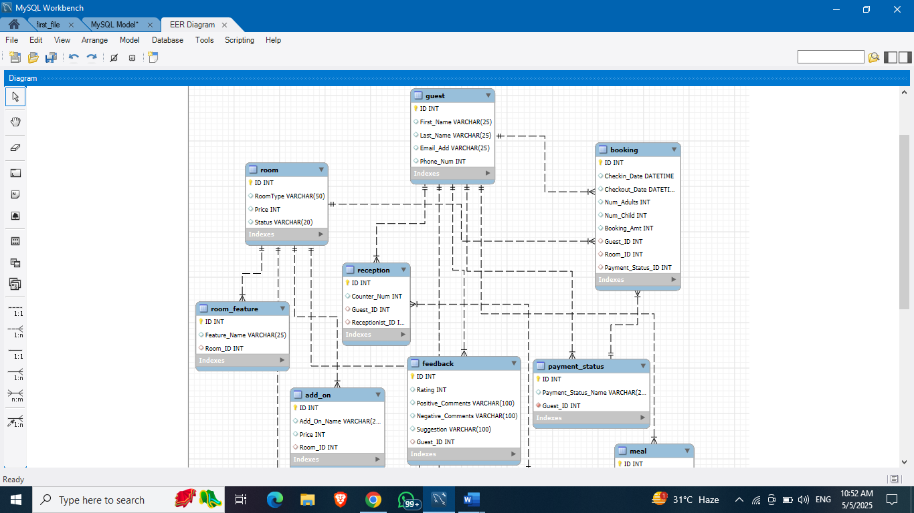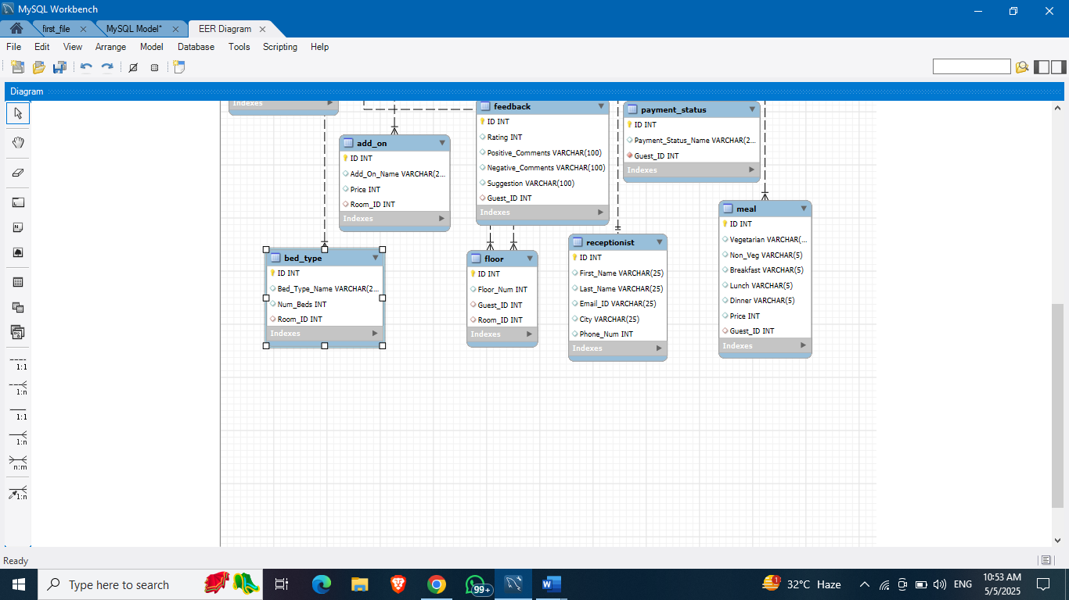

**6) Tables included in the Project:**

**1. Guest:**

* **ID:** this is a unique ID for a Guest
* **First_Name:** this is the name of a Guest
* **Last_Name:** this is the name of a Guest
* **Email_Add**: this is the email of the Guest
* **Phone_num:** this is the phone number of Guest

**2. Room:**

* **ID:** this is a unique ID for a Room
* **RoomType:** this is the various types of rooms available in hotel
* **Price:** this is the price of each type of rooms
* **Status:** this is the status of rooms like is it available or vacant.

**3. Booking:**

* **ID:** this is a unique ID for booking
* **Check_in_Date:** this is the entry date of Guests
* **Check_in_Date:** this is the exit date of Guests
* **Num_Adults:** this is the adult guests came to stay
* **Num_Child:** this is the children came to stay
* **Guest_Id:** this is the ID of the Guest which is referencing to the column ID of the Guest table.
* **Room_Id:** this is the ID of the Room which is referencing to the column ID of the Room table.
* **Payment_Id:** this is the ID of the Payment which is referencing to the column ID of the Payment table.

**4. Room_Feature:**

* **ID:** this is a unique ID for a Room_feature
* **Feature_Name:** this is the various types of features available in room
* **Room_Id:** this is the ID of the Room which is referencing to the column ID of the Room table.

**5. Reception:**

* **ID:** this is a unique ID for a Reception
* **Counter_Num:** this is the counter number in the hotel
* **Guest_Id:** this is the ID of the Guest which is referencing to the column ID of the Guest table.
* **Receptionist_Id:** this is the ID of the Receptionists which is referencing to the column ID of the Receptionists table.

**6. Receptionist:**

* **ID:** this is a unique ID for a Receptionist
* **First_Name:** this is the name of a receptionist
* **Last_Name:** this is the name of a receptionist
* **Email_Add**: this is the email of the receptionist
* **City:** this is the city of receptionist
* **Phone_num:** this is the phone number of receptionist

**7. Payment_Status:**

* **ID:** this is a unique ID for a Payment_Status
* **Status_Name:** this is the current status of payment of guests
* **Guest_Id:** this is the ID of the Guest which is referencing to the column ID of the Guest table.

**8. Add_on:**

* **ID:** this is a unique ID for a Add_on
* **Add_on_Name:** this is the items that one can add in their room
* **Price:** this is the price of each type of item added
* **Room_Id:** this is the ID of the Room which is referencing to the column ID of the Room table.

**9. Feedback:**

* **ID:** this is a unique ID for a Feedback
* **Rating:** this is the rating where guests has rated as their service
* **Positive_Comments:** this is the +’ve comment section for the guests
* **Negative_Comments:** this is the -’ve comment section for the guest
* **Suggestion:** this is the suggestion provided by the guests
* **Guest_Id:** this is the ID of the Guest which is referencing to the column ID of the Guest table.

**10. Meal:**

* **ID:** this is a unique ID for a Meal
* **Vegetarian:** this is the column which identify whether the guests were vegetarian or not.
* **Non-Veg:** this is the column which identify whether the guests were non-vegetarian or not.
* **Breakfast:** this implies that the guest has taken breakfast or not.
* **Lunch:** this implies that the guest has taken lunch or not.
* **Dinner:** this implies that the guest has taken dinner or not.
* **Guest_Id:** this is the ID of the Guest which is referencing to the column ID of the Guest table.

**11. Floor:**

* **ID:** this is a unique ID for a Floor
* **Floor_Num:** this is the floor number where the guests is staying.
* **Guest_Id:** this is the ID of the Guest which is referencing to the column ID of the Guest table.
* **Room_Id:** this is the ID of the Room which is referencing to the column ID of the Room table.

**12. Bed_Type:**

* **ID:** this is a unique ID for a bed_types
* **Bed_Type_Name:** this is the type of bed available in the rooms
* **Num_Bed:**  this is the number of beds available in the rooms
* **Room_Id:** this is the ID of the Room which is referencing to the column ID of the Room table.

**7) SQL Queries and Execution results:**

**1: List the guests name with their payment status respectively.**

SELECT g.First_Name, g.Last_Name, ps.Payment_Status_Name

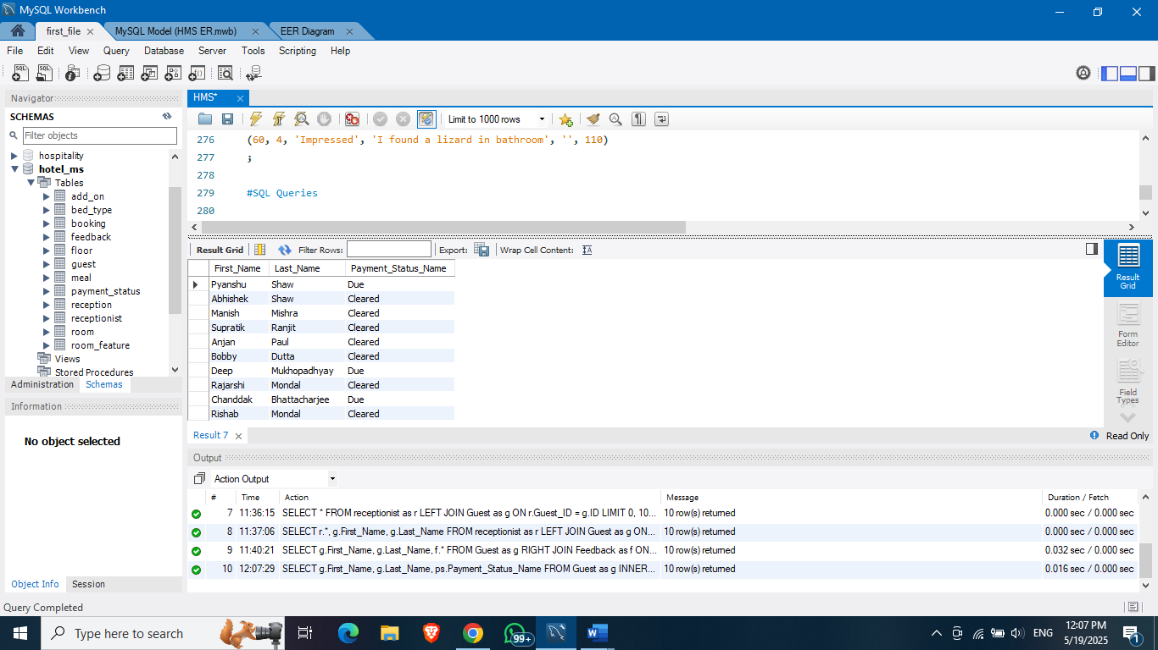FROM Guest as g

INNER JOIN Payment_Status as ps

ON g.ID = ps.Guest_ID;

**2: Adding a column in the Receptionists Table.**

ALTER TABLE Receptionist

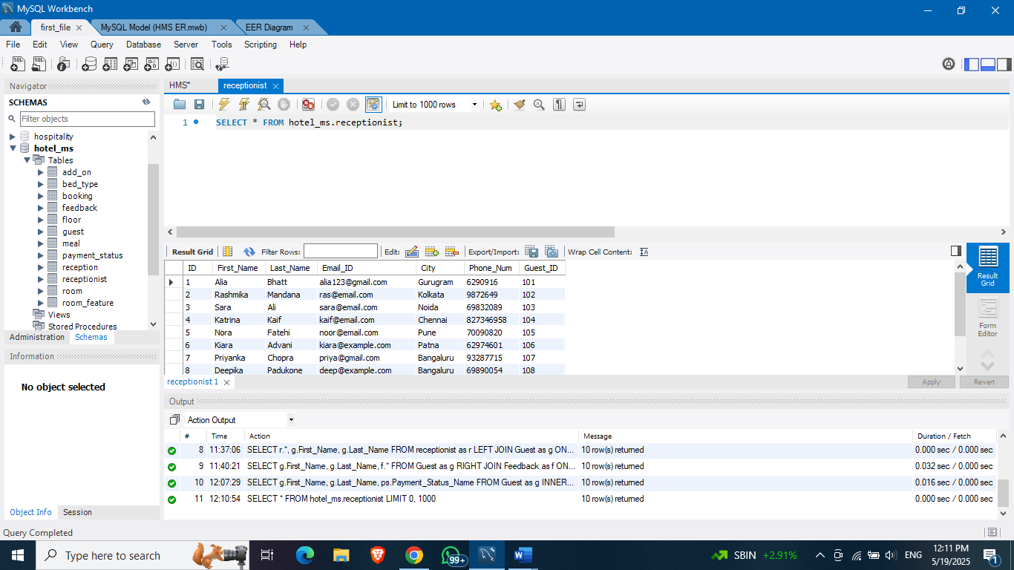ADD COLUMN Guest_ID INT NOT NULL;

**3: Lists the receptionists’ details along with Guest ID.**

SELECT r.*, g.First_Name, g.Last_Name

FROM Receptionist as r

LEFT JOIN Guest as g

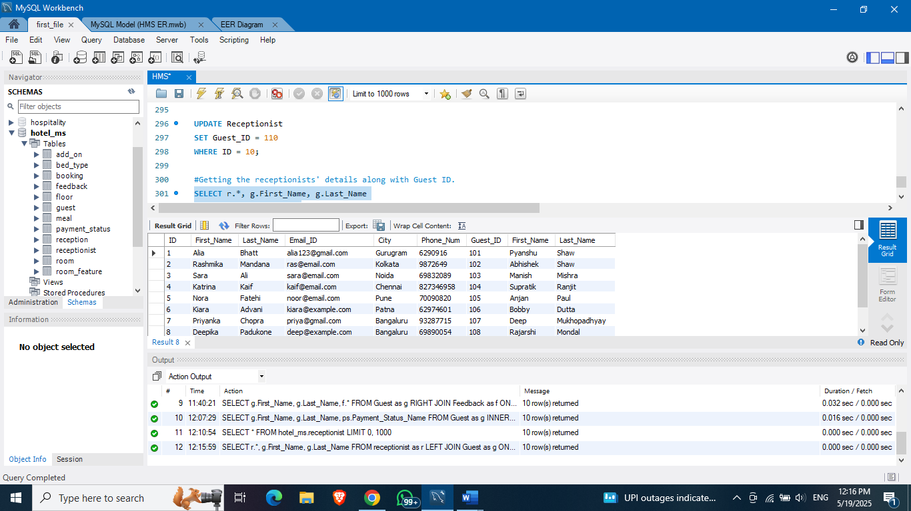ON r.Guest_ID = g.ID;

**4: Lists the Meals details of Guests.**

SELECT g.First_Name, g.Last_Name, m.*

FROM Guest as g

RIGHT JOIN Meal as m

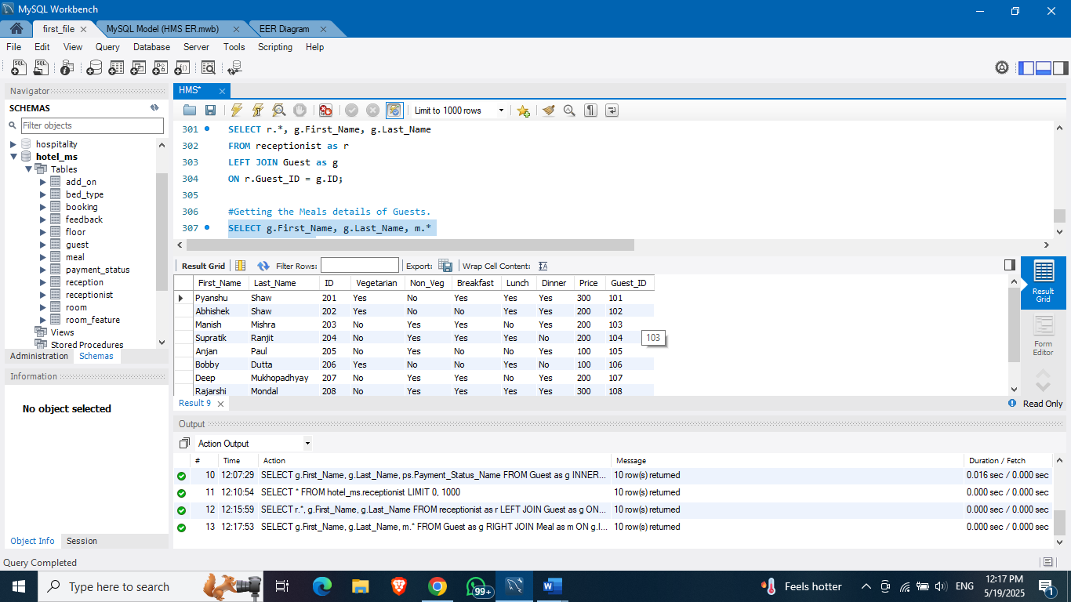ON g.ID = m.Guest_ID;

**5: Lists the Guests' Name with their feedbacks provided.**

SELECT g.First_Name, g.Last_Name, f.*

FROM Guest as g

RIGHT JOIN Feedback as f

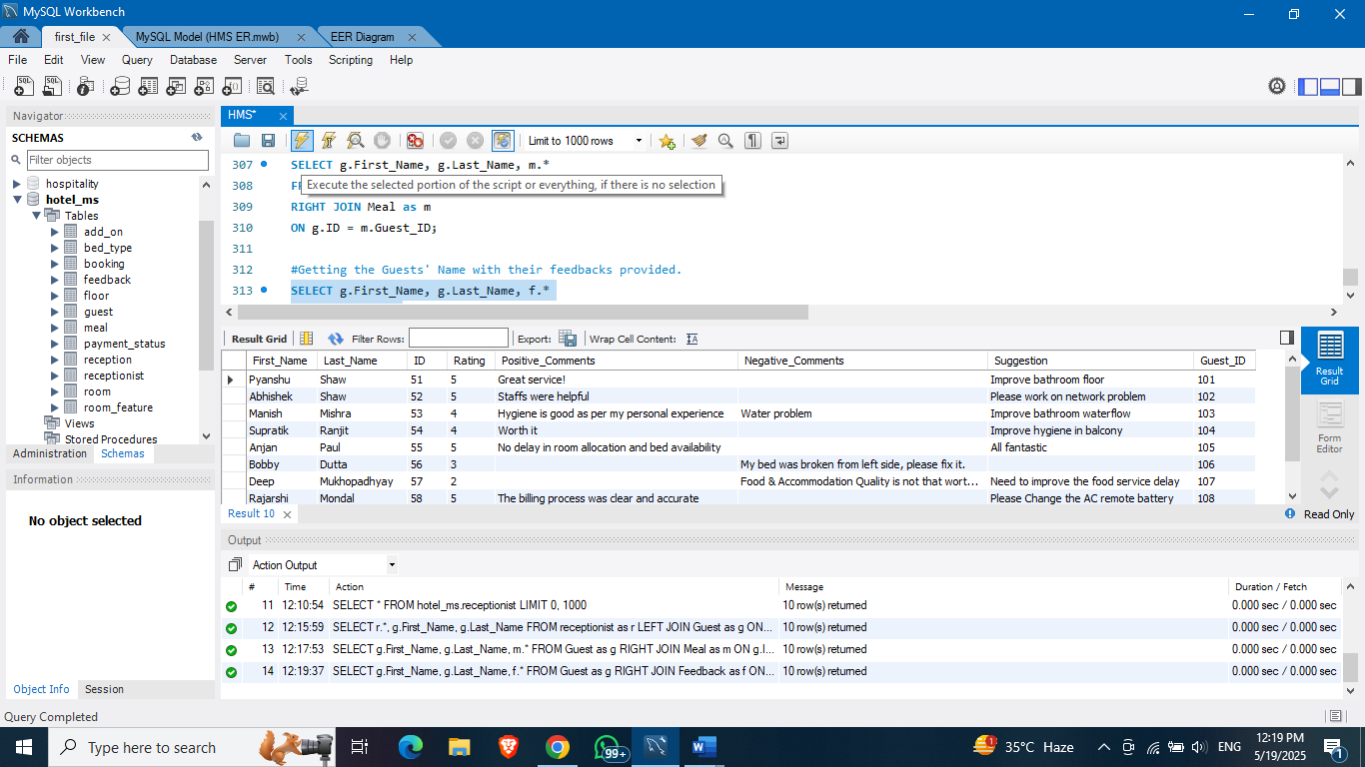ON g.ID = f.Guest_ID;

**8) Challenges faced in this project:**

* Ensuring data integrity through proper use of foreign keys and constraints.
* Handling concurrent bookings to avoid double reservations by adding unique constraints.
* Optimizing queries for faster execution, especially with large datasets.
* Designing a user-friendly schema that is scalable for future needs.

**9) Future Improvement Scope:**

* Integration with online booking platforms for real-time updates.
* Implementing advanced analytics for guests and preferences.
* Adding role-based access control for different staff members.
* Incorporating automated notifications for bookings and payments.
* Including timestamp columns for better tracking and auditing of records.

**10) Conclusion:**

The Hotel Management System developed using MySQL successfully streamlines key operations such as guest reservations, room management, billing, and staff coordination. By implementing a relational database structure, the system ensures efficient data storage, retrieval, and integrity. This project not only enhances operational efficiency but also provides a scalable solution for managing hotel resources, ultimately improving guests satisfaction and decision-making processes.